MINOR PROJECT

SYNOPSIS

ON

OPTICAL CHARACTER RECOGNITION ALGORITHM IN C++ LANGUAGE

JAYANT ARORA RITEYU ANAND
500045913 500031146

Under the guidance of

MR. VISHAL KAUSHIK

Assistant Professor

Department of VIRTUALIZATION,



Business Analytics and Optimization
Department of Analytics
School of Computer Science
UNIVERSITY OF PETROLEUM AND ENERGY STUDIES

Dehradun-248007

Jan-May, 2018

Centre for Information Technology
University of Petroleum & Energy Studies, Dehradun

Project Proposal Approval Form (2017-18)

Minor | II

PROJECT TITLE –

Optical Character Recognition Algorithm of Devanagari Script using in C++ language.

ABSTRACT –

Image processing has been one of the interesting topics in IT industry. The Project Title is Optical Character Recognition (OCR), which is a major application in this field. When we see an object, our brain or general recognition system starts extracting important features of the object and then finds the closest match in the whole collection of objects. This place can be referred to as a standard library. For humans this task seems to be pretty simple but for a machine, it’s difficult! For Devanagari script in C++ language, we will represent an algorithm for implementation of Optical Character Recognition to translate images of character of typewritten characters into electronically editable format by reserving font properties. It can be done using pattern-matching algorithm. Every character of Devanagari script can be recognized and be easily converted to any editable format.

INTRODUCTION-

Optical character recognition, usually abbreviated to OCR, is the mechanical or electronic conversion of scanned images of handwritten, typewritten or printed text into machine-encoded text. It relies on a set of learned characters. Generating learned set is quite simple. Learned set requires an image file with the desired characters in the desired font to be created, and a text file representing the characters in this image file. Learned set is basically coordinates related information.
It is widely used as a form of data entry from some sort of original paper data source, whether documents, sales receipts, mail, or any number of printed records. It is a common method of digitizing printed texts so that they can be electronically searched, stored more compactly, displayed on-line, and used in machine processes such as machine translation, text-to-speech and text mining. All OCR systems include an optical scanner for reading text, and sophisticated software for analyzing images. Most OCR systems use a combination of hardware (specialized circuit boards) and software to recognize characters, although some inexpensive systems do it entirely through software. Advanced OCR systems can read text in large variety of fonts, but they still have difficulty with handwritten text. The potential of OCR systems is enormous because they enable users to harness the power of computers to access printed documents. OCR is already being used widely in the legal profession, where searches that once required hours or days can now be accomplished in a few seconds. OCR is a field of research in pattern recognition, artificial intelligence and computer vision. Researchers proved that the recognition of both barcodes and printed text through Optical Character Recognition is reliable and significantly accelerates data processing.

PROBLEM STATEMENT –

To develop an Optical Recognition System for online/offline handwriting recognition for Devanagari Script.

PROJECT SCOPE –

The system can be used by multiple users .We can do this this by improving the software for recognizing the handwriting for more than one user. Also if we can take the stroke information and give it to our systems, then it will be possible to recognize even cursive script also.
The recognized characters are stored in the text file. We can add words to the sound file and invoke them through the program, so that the recognized words can be read aloud. Thus we can make the computer read handwritten documents.

LITERATURE REVIEW –

Now a days, there are software’s for recognizing only the English characters. It recognizes and stores the characters in ASCII format. Optical character recognition, usually abbreviated to OCR, is the mechanical or electronic translation of images of handwritten, typewritten or printed text (usually captured by a scanner) into machine-editable text. OCR is a field of research in pattern recognition, artificial intelligence and machine vision. Character recognition originated as early as 1870 when Carey invented the retina scanner, which is an image transmission system using photocells. It is used as an aid to the visually handicapped by the Russian scientist Tyurin in 1900. However, the first generation machines appeared in the beginning of the 1960s with the development of the digital computers. It is the first time OCR was realized as a data processing application to the business world [Mantas, 1986]. The first generation machines are characterized by the “constrained” letter shapes which the OCRs can read. Sandhya Arora in 2002, used four feature extraction techniques namely, intersection, shadow feature, chain code histogram and straight line fitting features. Shadow features are computed globally for character image while intersection features, chain code histogram features and line fitting features are computed by dividing the character image into different segments. On experimentation with a dataset of 4900 samples the overall recognition rate observed was 92.80% for Devanagari characters. R. Bajaj, L. Dey, S. Chaudhari et al , employed three different kinds of features, namely, the density features, moment features and descriptive component features for classification of Devanagari Numerals. They proposed multi classifier connectionist architecture for increasing the recognition reliability and they obtained 89.6% accuracy for handwritten Devanagari numerals. "Intelligent" systems with a high degree of recognition accuracy for most fonts are now common. Some systems are even capable of reproducing formatted output that closely approximates the original scanned page including images, columns and other non-textual components. One study based on recognition of 19th and early 20th century newspaper pages concluded that character-by-character OCR accuracy for commercial OCR software varied from 71% to 98%; total accuracy can only be achieved by human review. Other areas—including recognition of hand printing, cursive handwriting, and printed text in other scripts (especially those East Asian language characters which have many strokes for a single character)—are still the subject of active research.

OBJECTIVES –

-To develop a software that can recognize a printed Devanagari character.
-This software will be able to scan and recognize a character written in Devanagari Script.

METHODOLOGY –

Extraction of Character Regions from an Image, Segmentation of the Image into Text and Background, Conditioning of the Image, Segmentation of Characters, Feature Detection and then classification. We will use four basic algorithms while doing this project, image labelling, finding boundary and generating X & Y co-ordinate pixel array, matching connected pixels with learned set, forming words. A good example is the constructor of a building, taking physical copies of blueprints as an input and using OCR technique put them onto computers for further work. At the present moment, OCR is the best method for digitizing typed pages of text. There are three basic techniques on which OCR works: Pre-processing, Character Recognition, and Post processing. We will head directly to character recognition, it will use four basic algorithms, image labelling, finding boundary, matching connected pixels with learned set and forming words. The recognizing process is to interpret images. The library templates and configuration threshold will determine the accuracy of interpretation of the OCR.

SYSTEM REQUIREMENTS –

- Imaging Hardware( Digital Camera, Smart Phone)
- Min. 256 mb of RAM
- Min. Intel Pentium 2 processor
- 5 GB Hard Disk

SCHEDULE/PERT CHART –

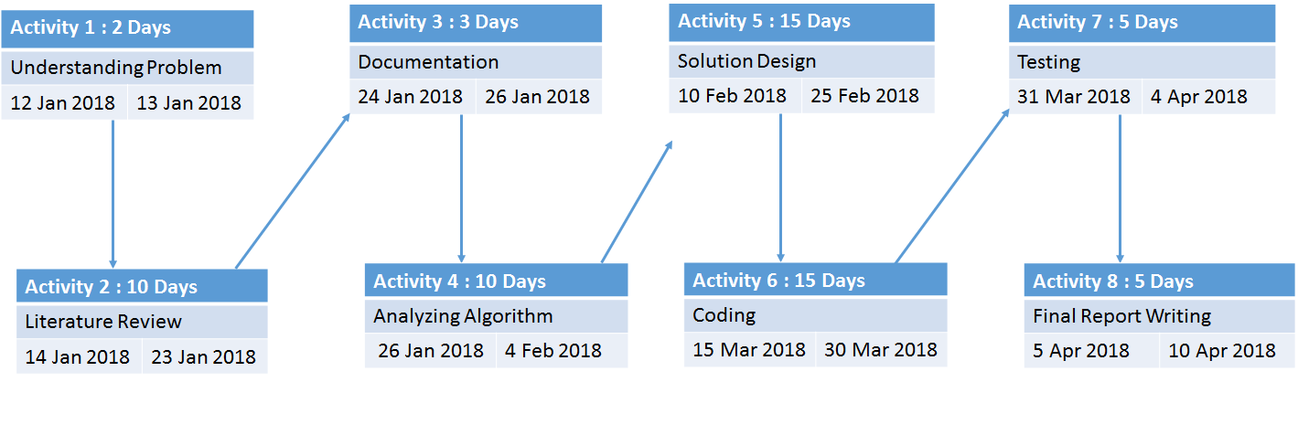

REFERENCES-

- Digital Image Processing by R.C. Gonzalez and R. E. Woods.
- Ivan Dervisevic Machine Learning Methods for Optical Character Recognition December 18, 2006.
- Reena Bajaj, Lipika Dey, and S. Chaudhury, “Devnagari numeral recognition by combining decision of multiple connectionist classifiers”, Sadhana, Vol.27, part. 1, pp.-59-72, 2002.
- Sandhya Arora, “Combining Multiple Feature Extraction Techniques for Handwritten Devnagari Character Recognition”, IEEE Region 10 Colloquium and the Third ICIIS, Kharagpur, INDIA, December 2008.
- Fahim Irfan Alam, Bithi Banik. (2013) Offline isolated bangla handwritten character recognition using spatial relationships. 2013 International Conference on Informatics, Electronics and Vision (ICIEV), 1-6.

Project Outcomes –

PO1 | The end user will be able to scan handwritten documents in Devanagari script.
PO2 | The user would be able to scan the documents and convert them into different formats.
PO3

Project Panel -

Faculty Name | Signature | Approve/Comments

Approved By

Mr. Vishal Kaushik

Dr. T.P. Singh
(Project Guide)

(Program Head)

